**TV REMOTE CONTROL JAMMER**

**A PROJECT REPORT**

***Submitted by***

**NAME OF THE CANDIDATES**

***Piyush Pamnani PA-26***

***Ruchin Shroff PA-27***

***in Digital Electronics***

***of***

**Second Year**

in



SCHOOL OF ENGINEERING

**DR VISHWANATH KARAD MIT - WORLD PEACE UNIVERSITY**

**September 2020**

**COMPONENTS REQUIRED**

|  |  |  |  |
| --- | --- | --- | --- |
| S.No | Components | Range | Quantity |
| 1. | NE 555 Timer | - | 1 |
| 2. | 1N4148 Diode | - | 2 |
| 3. | Potentiometer | 10KΩ | 1 |
| 4. | Battery | 9V | 1 |
| 5. | Capacitor | 10nF | 1 |
| 6. | Resistors (470Ω, 1KΩ, 5.6Ω) | - | 1 |
| 7. | Transistor NPN | 200-900 mV | 1 |
| 8. | IR LED | - | 1 |

**INTRODUCTION**

As there are many people in our family and everyone has different interests, the TV remote goes to the person who is the eldest in the house and not to the one who switched it on to watch the channel of his/her choice. So this circuit is made for fun, as the person who has switched on the TV will not be disturbed by anyone else, as the TV remote control will be jammed using this circuit. This circuit is made to provide convenience to the person who has switched on the TV for watching a channel of his/her own interest without any disturbance!

**DESCRIPTION OF COMPONENTS**

IC 555 TIMER RATED

IC 555 timer is a one of the most widely used IC in electronics and is used in various electronic circuits for its robust and stable properties. It works as square-wave form generator with duty cycle varying from 50% to 100%, Oscillator and can also provide time delay in circuits. The 555 timer got its name from the three 5k ohm resistor connected in a voltage-divider pattern which is shown in the figure below. A simplified diagram of the internal circuit is given below for better understanding as the full internal circuit consists of over more than 16 resistors, 20 transistors, 2 diodes, a flip-flop and many other circuit components. The 555 timer comes as 8 pin DIP (Dual In-line Package) device. There is also a 556 dual version of 555 timer which consists of two complete 555 timers in 14 DIP and a 558 quadruple timer which is consisting of four 555 timer in one IC and is available as a 16 pin DIP in the market.

**IR TRANSMITTER AND RECEIVER**

are used to control any device wirelessly, means remotely. TV remote and TV are the best example of IR transmitter and receiver. TV generally consist TSOP1738 as the IR receiver, which senses modulated IR pulses and convert them into electrical signal.

**IR Receiver (TSOP17XX)**

TSOP17XX receives the modulated Infrared waves and changes its output. TSOP is available in many frequency ranges like TSOP1730, TSOP1738, TSOP1740 etc. TSOP1738 reacts when it receives the IR radiation modulated at 38 kHz.. Means  it detects the IR which is switching On and Off at the rate of 38kHz. TSOP’s output is active low, means its output is remains HIGH when there is no IR, and becomes low when it detects IR radiation. TSOP operates on particular frequency so that other IRs in the environment can’t interfere, except the modulated IR of particular frequency. It has three pins, Ground, Vs (power), and OUTPUT PIN.

#### **IR LED (Infrared Transmitter)**

IR LED is a special type of LED that emits Infrared rays of the Electromagnetic Spectrum. The wavelength of Infrared Rays is greater than that of Visible light and hence they are invisible to human eye.

A typical IR LED emits infrared rays in a wavelength range of 740 – 760 nm. There are many sources of infrared light like sun, light bulbs, all hot items and even human body.

So, in order to prevent interference and false triggering, we will modulate the infrared light. The modulated signal can only be demodulated by the appropriate IR Receiver.

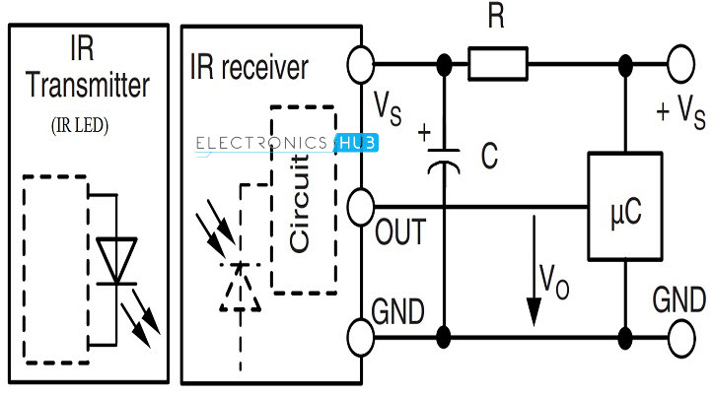

An IR transmitter-receiver circuit

**POTENTIOMETER**

The instrument designs for measuring the unknown voltage by comparing it with the known voltage, such type of instrument is known as the potentiometer. In other words, the potentiometer is the three terminal device used for measuring the potential differences by manually varying the resistances. The known voltage is drawn by the cell or any other supply sources.The potentiometer uses the comparative method which is more accurate than the deflection method. So, it is mostly used in the places where higher accuracy is required or where no current flows from the source under test. The potentiometer is used in the electronic circuit, especially for controlling the volume.

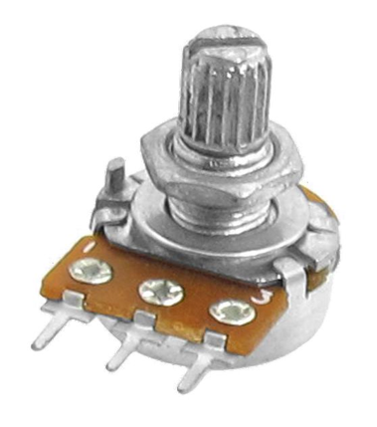

A potentiometer.

**ELECTROLYTIC CAPACITORS:**

An electrolytic capacitor is a polarized capacitor whose anode or positive plate is made of a metal that forms an insulating oxide layer through anodization. This oxide layer acts as the dielectric of the capacitor. A solid, liquid, or gel electrolyte covers the surface of this oxide layer, serving as the cathode or negative plate of the capacitor. Due to their very thin dielectric oxide layer and enlarged anode surface, electrolytic capacitors have a much higher capacitance-voltage product per unit volume than ceramic capacitors or film capacitors, and so can have large capacitance values. There are three families of electrolytic capacitor: aluminum electrolytic capacitors, tantalum electrolytic capacitors, and niobium electrolytic capacitors.

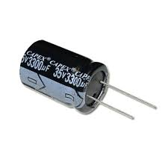

An Electrolytic Capacitor

**WORKING PRINCIPLE**

The idea behind the TV remote control jammer is sending a constant IR pulse with the carrier frequency of the transmitter. Hence, the result will be non-accepted signal from the receiver and therefore no action will be taken.

Basically the TV remote emits a sequence of pulses when you press a button. IR transmitter is fixed to the surface of the TV remote. This IR transmitter emits the pulses in unique configuration for each button.

IR receiver, which is arranged on the TV, will receive these sequence of pulses that are transmitted by the TV Remote and identifies which button is pressed in TV remote.

Generally Philips TV remotes follows RC5 (Remote Control) protocol. This protocol was developed by Philips in the late 1980s. According to this protocol, for each button, Remote transmits 14 bits.

**DESIGN**:

The circuit is designed to produce a 38 KHz signal. The main component in this circuit is 555 Timer. Here, it is operated in astable multivibrator mode. In this circuit, 2nd and 6th pins are shorted to allow the triggering after every timing cycle and these two pins are grounded through the capacitor. 4th pin of 555 timer is connected to supply to avoid sudden resets. 10KΩ pot is used to adjust the frequency of 555 timer. The current through the IR-LED is limited to 100mA because of two 1N4148 diodes, as these form constant current arrangement when combined with transistor and resistor.

This **TV remote control jammer circuit** confuses the infra-red receiver in a TV. It produces a constant signal that interferes with the signal from a remote control and prevents the TV detecting a channel-change or any other command. This allows you to watch your own program without anyone changing the channel!! The circuit is adjusted to produce a 38 kHz signal. The IR diode is called an Infra-red transmitting Diode or IR emitter diode to distinguish it from a receiving diode, called an IR receiver or IR receiving diode. (A **Photo diode** is a receiving diode). There are so many IR emitters that we cannot put a generic number on the circuit to represent the type of diode. Some types include: CY85G, LD271, CQY37N (45¢), INF3850, INF3880, INF3940 (30¢). The current through the [IR LED](https://www.engineersgarage.com/electronic-components/ir-infrared-led) is limited to 100mA by the inclusion of the two [1N4148 diodes](https://www.engineersgarage.com/electronic-components/1n4148-diode), as these forms a constant-current arrangement when combined with the transistor and 5R6 resistor.

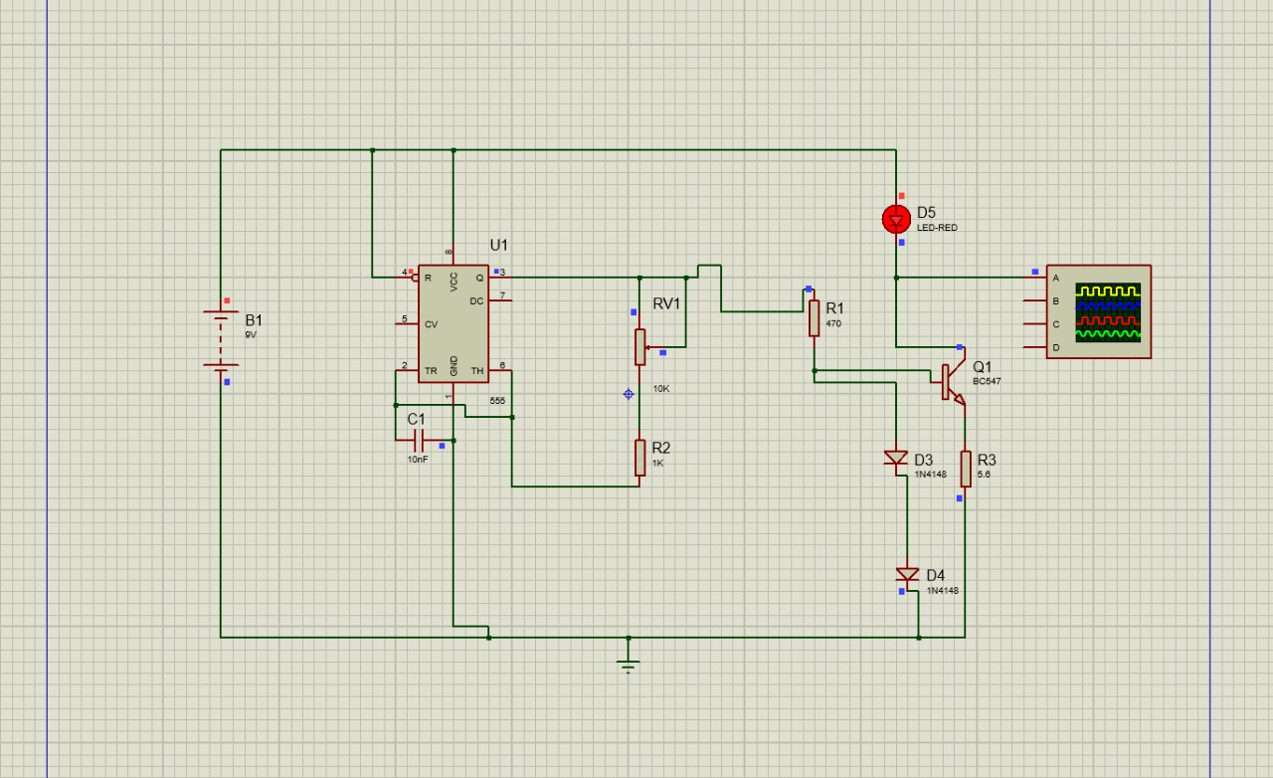

**RESULT:**

We were successfully able to implement the circuit and were able to generate a signal of constant frequency.

**CONCLUSION:**

This TV remote control jammer was built to our satisfaction. This project and implementation is about how to prevent other from changing channels or volume on the TV.

**ADVANTAGES:**

* We can use this circuit to jam the remote signals so that the other people cannot change the channel while watching our favorite program on TV.
* It will not affect the signal receiving capacity of the TV.

**DISADVANTAGES:**

* The circuit should be tuned correctly to 38 KHz frequency to get accurate results.